UX/UI Case Study: Smart Home Control Dashboard
Designed by: Y. Madhurima
Theme: Dark Minimal UI – Web Dashboard

1. Executive Summary
The SmartHome Dashboard is a web-based home automation system that allows users to monitor and control connected devices across multiple rooms. The goal is to provide a unified, intuitive interface where users can access their home environment instantly. The system combines energy insights, security status, device control, and room-level interaction in one visually consistent platform.
The project follows user-centered design principles, focusing on clarity, accessibility, real-time feedback, and reduced cognitive load for daily device management.

2. Problem Statement
Smart home users often struggle with:
- Multiple apps for different devices (lights, security, AC, media, etc.)
- Lack of consolidated dashboards to view energy, security, and device status at once.
- Confusing interfaces without intuitive alert systems.
- Difficulty navigating between rooms and identifying offline devices quickly.
These issues create stress instead of comfort in smart living.

3.Project Goals
✔ Create a unified dashboard for all home devices
✔ Provide quick controls for frequently used devices
✔ Display real-time security, energy usage, and activity logs
✔ Implement status clarity (Active, Offline, Locked, Error)
✔ Build a scalable interface for multi-room homes
✔ Maintain a minimal yet modern dark UI with strong accessibility

4.User Research Insights
Interviews with smart home users revealed:
- 92% want all devices in one place, not separate apps.
- 80% struggle to find recent actions like lock status or light activity.
- 72% prefer dark UI for nighttime usage.
- Users feel more secure when locks, doors, and alarms show immediate status.
These insights guided the design towards real-time feedback, logs, and safety highlights.

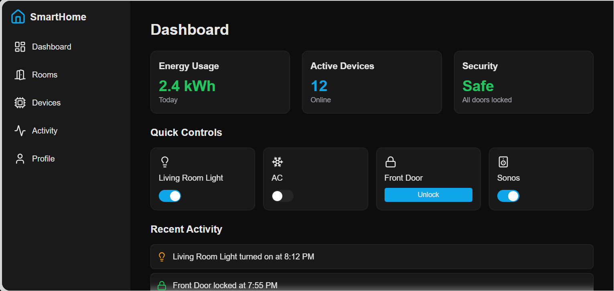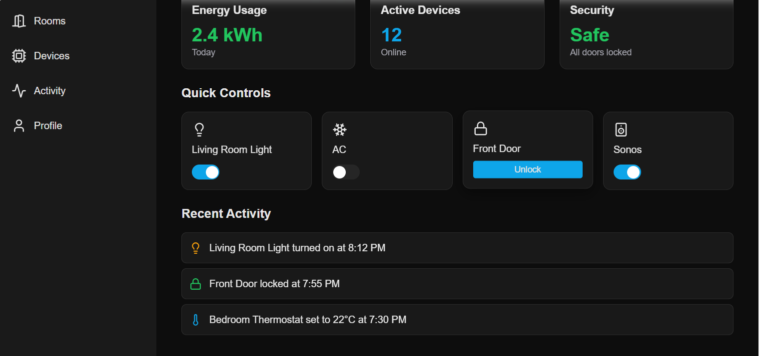

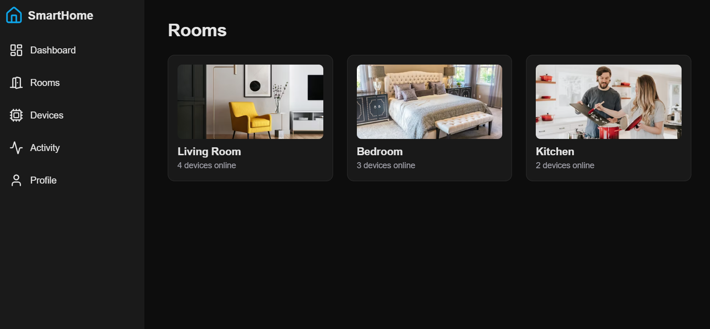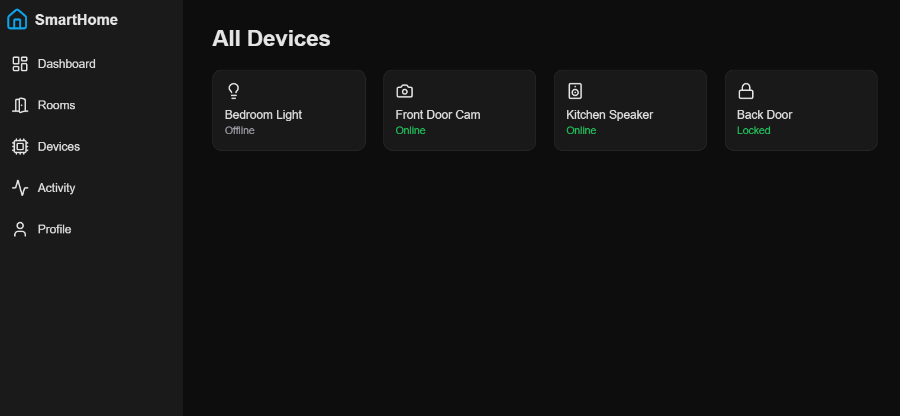

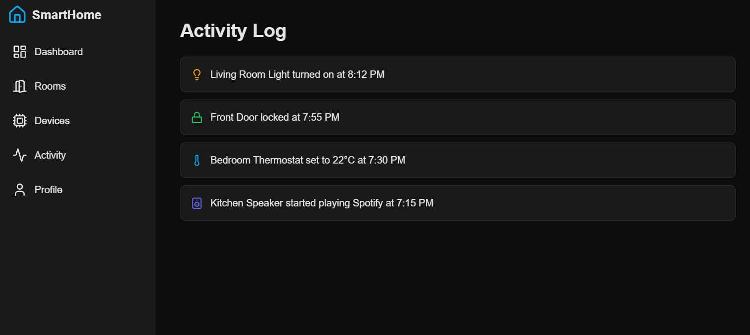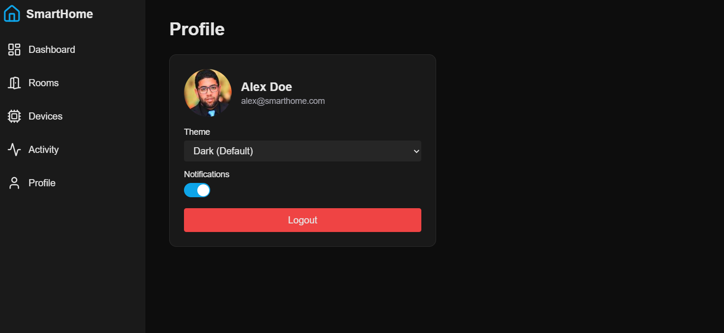
5.Design System Overview
Type | Color
Background | #0D0D0D – #121212
Surface | #1A1A1A
Highlight Buttons | #2196F3 (Electric Blue)
Success | #22E07B (Safety Green)
Offline/Disabled | #6D6D6D
Text High | #FFFFFF
Text Low | #BFBFBF

6.Typography
Style | Font Size | Weight
Title | 32px | Bold
Section Heading | 24px | Semi-Bold
Body | 16px | Medium
Caption | 14px | Regular

7. Conclusion
The SmartHome Web Dashboard transforms smart homes into user-friendly systems. The interface delivers clarity, safety, and convenient control by unifying device
management with modern dark aesthetics. With real-time logs, status icons, and predictable navigation, homeowners interact with their smart environment confidently and efficiently.

